# Module 12: Cloud Forensics

# Screenshots

Lara Alofi

2110886

Y

Computer Hacking Forensic Investigator (CHFI)

Lab Session Identifiers

1. <https://labclient.labondemand.com/LabClient/c7a120d8-8164-400e-b3a9-a206a1710d4a>

Username on EC-Council System

1. 2110886@uj.edu.sa

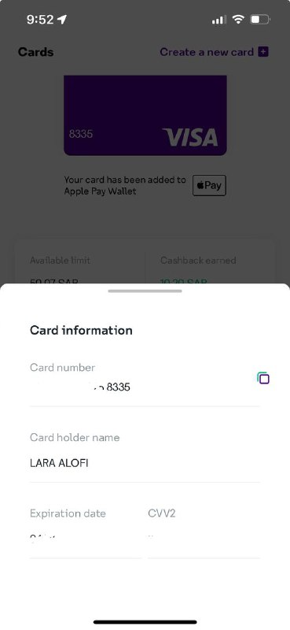

I used STCPay card but this problem appeared and I tried another STCPay card but the same problem still exists

Lab 02

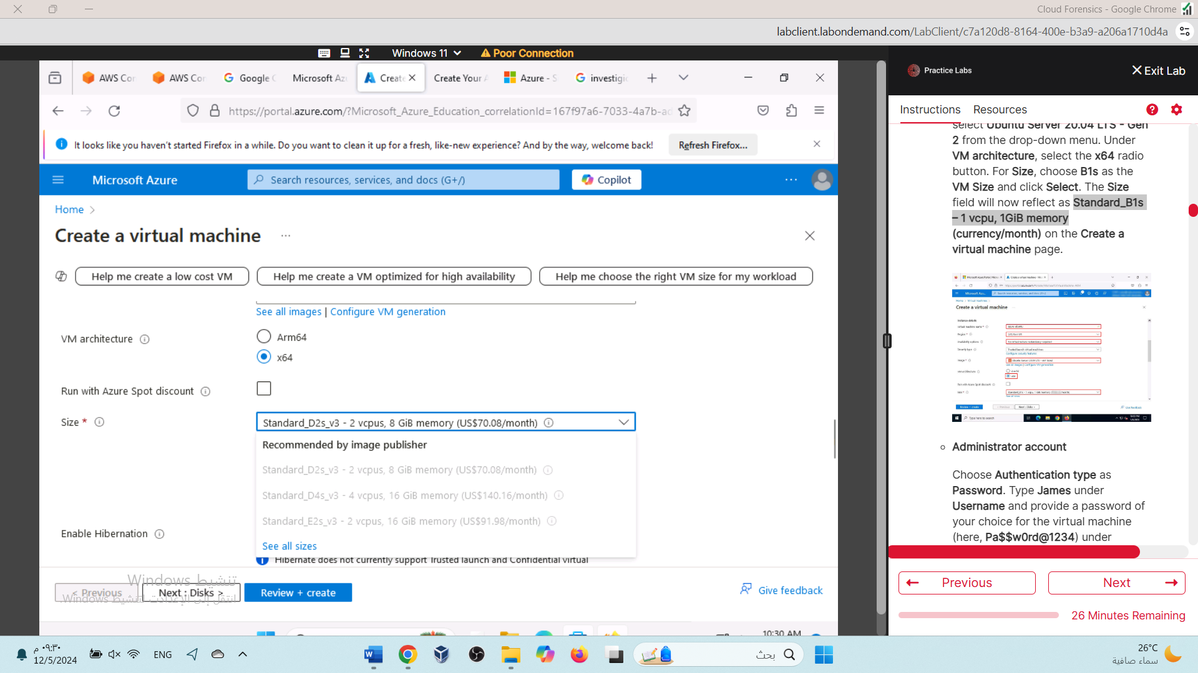

I click on see all size then search for **Standard_B1s – 1 vcpu, 1GiB memory**

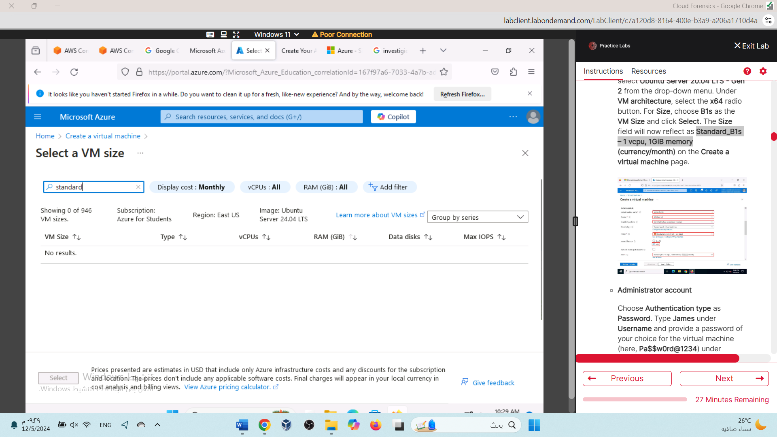

The size we require does not appear even when searching for it, and all the other sizes available are for a free.

## Lab3:

The message that appears when creating Windows Server for Workstation: I cannot complete it because the free version does not support that.

